|  |  |  |
| --- | --- | --- |
|  | **SRI KRISHNA COLLEGE OF TECHNOLOGY**  **An Autonomous Institution | Accredited by NAAC with 'A' Grade**  **Affiliated to Anna University | Approved by AICTE**  **KOVAIPUDUR, COIMBATORE 641042** |  |

#### CYBER GAMING

**A PROJECT REPORT**

***Submitted by***

#### GOWSHICK RAJA B

**727822TUEC037**

*in partial fulfilment for the award of the degree*

Of

#### BACHELOR OF ENGINEERING

**IN**

**ELECTRONICS AND COMMUNICATION ENGINEERING**

**JANUARY 2023**

## CERTIFICATE

#### BONAFIDE CERTIFICATE

Certified that this project report **“Cyber gaming”** is the Bonafide work of **GOWSHICK RAJA B** who carried out the project work under my supervision.

SIGNATURE SIGNATURE

Dr. G. Shanthi Ms. S. Muthulakshmi

**HEAD OF THE DEPARTMENT SUPERVISOR**

Professor Assistant Professor

Department of ECE Department of IT

Sri Krishna College of Technology Sri Krishna College of Technology Kovaipudur Kovaipudur

Coimbatore-42. Coimbatore-42.

Certified that the candidates were examined by us in the Project Work viva- voce examination held on ............................... at Sri Krishna College of Technology, Coimbatore -641 042.

**INTERNAL EXAMINER EXTERNAL EXAMINER**

## ACKNOWLEDGEMENT

#### ACKNOWLEDGEMENT

First and foremost, I thank the **Almighty** for being my light and for showering his gracious blessings throughout the course of this project.

I am grateful to my beloved Dean-Academics **Dr. Manju P &** Dean-Administration **Dr R Ramesh Kumar** for their tireless and relentless support.

I extend my sincere thanks to my Head of the Department **­­Dr. G. Shanthi** her encouragement and inspiration.

I am greatly indebted to my Industry Mentor **Mr. Suresh Gupta** & Project guide **Ms. S. Muthulakshmi** Assistant Professor, Department of **IT** for their valuable guidance and suggestions in all aspects that aided me to ameliorate my skills.

I am thankful to all those who have directly and indirectly extended their help to me in completing this project work successfully.

## ABSTRACT

### ABSTRACT

"Cyber Gaming" is an online community and e-sports gaming platform that hosts tournaments for players worldwide. It offers players the opportunity to create their own accounts, participate in tournaments, and win attractive rewards such as gift coupons, gift cards, and electronic cash. The platform's tournaments offer players the chance to compete against each other in various games, making it an engaging and fun community for gamers. The rewards and cash prizes offered by Cyber Gaming serve as a great incentive for players to participate, making it an appealing platform for avid gamers. Overall, Cyber Gaming is an exciting and rewarding platform for gamers who are interested in E-sports tournaments.

The platform provides opportunities to those people who want to make a living out gaming and don’t know where to start with. It also allows space for players who participate for the experience of participation and also to those who want to game in tournaments alongside players from all around the world.

When you are special at something why do it for free or for pleasure that you get out of it instead of starting to make an earning out of the same special talent or hobby. Just another opportunity for people out there who want to experience and interact with the world.

## LIST OF FIGURES

#### LIST OF FIGURES

|  |  |  |
| --- | --- | --- |
| S.NO | FIGURE NAME | PAGE.NO |
| 2.1 | Sign Up Page | 20 |
| 2.2 | Login Page | 24 |
| 3.1 | Landing Page | 30 |
| 3.2 | Home Page – What’s New | 37 |
| 3.3 | Home Page – Chat Box Input & Latest records | 37 |
| 4.1 | Categories page | 46 |
| 4.2 | Help center page | 51 |

## LIST OF ABBREVIATIONS

#### LIST OF ABBREVIATIONS

|  |  |
| --- | --- |
| ABBRIVATIVE | ABBRIVATION |
| CG | Cyber Gaming |
| HTML | Hyper Text Markup Language |
| CSS | Cascading Style Sheet |
| JS | Java Script |
| E-Sports | Electronic Sports |
| 2FA | Two Factor Authentication |
| CTA | Computed Tomography Angiography |

***TABLE OF CONTENTS***

**TABLE OF CONTENTS**

|  |  |  |
| --- | --- | --- |
| CHAPTER NO. | CONTENTS | PAGE NO. |
|  | **Abstract** | **6** |
|  | **List of figures** | **8** |
|  | **List of abbreviations** | **10** |
|  | **Table of contents** | **12** |
| 1 | **Introduction**   * 1. **Problem definition**   2. **Overview** | **14** |
| 2 | **Security technique**  **2.1. Sign up and login page**  **2.2. Additional securities**  **2.3. At CG Site – Sign UP** | **17** |
| 3 | **Website**  **3.1. Landing page and Home Page**  **3.2. At CG Site – Landing Page**  **3.3. At CG Site – Home Page** | **28** |
| 4 | **Additional pages**  4.1. Categories Page  4.2. Help Center | **45** |
| 5 | **Conclusion and future scope**  5.1. Conclusion  5.2. Future Scope | **55** |
| 6 | **Reference** | **58** |

## INTRODUCTION

### CHAPTER 1 INTRODUCTION

This chapter describes about the problem statement and about our Website.

#### PROBLEM DEFINITION

Online gaming can give you the space to be yourself and explore different personalities in a safe environment without anyone knowing you in the physical world. This gives players comfort in being able to freely explore thoughts and feelings they might not feel comfortable doing anywhere else. But players wanted more from just playing games for fun, they wanted to turn this gaming habit into a base of income or their main career.

This problem made its way to the birth of gaming tournaments. The earliest known video game competition took place on 19 October 1972 at Stanford University for the game Spacewar. Stanford students were invited to an "Intergalactic pacewar Olympics" whose grand prize was a year's subscription for Rolling Stone. Later many tournaments such as nationwide arcade video game tournaments, local tournaments, events etc. started to emerge into the world of players. These tournaments were benefited by many as it acted as a platformed for them to launch a new product, release a new game, distribute attractive prizes to attract every player out there and providing special offers and announcements.

Players still are hyped of these tournaments with great and attractive prizes. But not all players are able to participate in these tournaments due to various reasons like lack of skills, work background, incompatible devices, existing champions overpowering them etc. All these problems have solutions right in our Esports Gaming Platform – Cyber Gaming.

Esports, short for electronic sports, is a form of competition using video games. Esports often takes the form of organized, multiplayer video game competitions, particularly between professional players, individually or as teams. Although organized competitions have long been a part of video game culture, these were largely between amateurs until the late 2000s, when participation by professional gamers and spectatorship in these events through live streaming saw a large surge in popularity. By the 2010s, esports was a significant factor in the video game industry, with many game developers actively designing and providing funding for tournaments and other events.

#### OVERVIEW

Our main focus is to develop a far better simple esports community through our website. Where each and every player can participate in various events and tournaments and the champions get hands on different prizes which include game passes, discount cards for in-game purchase, online currency which can be transferred to their bank accounts on their will.

Promoting the gaming career or the players hobby in the field with rewards for them to keep them motivated throughout the time. Players will no longer have to worry about playing with an opponent of higher levels or higher skill set as players here will be matched according to their level and skill set with the data that is continuously monitored and updated throughout a player’s time spent in the community. Players will be provided with The Cyber Gaming Currency – Tokens, which can be earned by winning tournaments and events and which can be spent by participating special evets as entry fee, players also can withdraw these Tokens to their bank accounts. (The value of Tokens may differ when converted to different country’s currency, Players ae to be aware of this.)

## SECURITY TECHNIQUE

### CHAPTER 2

**SIGN UP AND LOGIN**

The login page allows a user a gain access to an application by entering their username and password or by authenticating using a social media login.

#### USE OF A LOGIN OR A SIGN-UP PAGE

A Login or a Sign-up page is very common among any type of secured applications and its widely used on the internet for authenticating the user before presenting the secured pages of the web applications. To access our community and gain its advantages a player must sign up or login in, this authentication is done through a special web called the sign up or login in page. This page asks the player to enter credentials and after successful validation the players are presented with the secured part of the community.

This page usually asks for an email or a username or a phone number and a respective password for this newly created account which follows a certain criterion.

#### HOW ARE THESE PAGES CREATED

A login form or a sign-up form is simple HTML Form element with one input for username and other input for password. These are two buttons one for submitting the form and the other for reset of the form. There might be links for forgot password and register new account. With these elements complete login form is developed. Where as a sign-up page has additional fields to reconfirm the password created and to check the terms and conditions of using the site and accessing the community. Languages used to create these pages are HTML, CSS and JS.

#### HOW DO THEY WORK

The process is fairly simple, players input their credentials on the website’s login form. That information is then sent to the authentication server where the information is compared with all the user credentials on file. When a match is found, the system will authenticate users and grant them access to their accounts.

#### ADDITIONAL SECURITIES

#### TWO FACTOR AUTHENTICATION

Two factor authentication (2FA) is an identity and access management security that requires two forms of identification to access resources and data. Two factor authentication gives businesses and websites the ability to monitor and help safeguard their most vulnerable information and networks. It verifies the player’s identity by using two or three factors, sometimes like a passcode, something that only you know, something like a key, something that is biometric like finger print or eye scan or facial recognition.

* + 1. **FINGERPRINTS**

In the past, fingerprints were recorded by the application of ink to the finger which was then pressed to paper to give an impression. Fingerprints have been used as human identification long ago. People are familiar with it-and they trust it. Hand geometry is even older than digital fingerprinting; it was first used for security purposes on Wall Street more than 20 years ago. However, in Malaysia, the idea of hand scanning is not very popular compared to fingerprints.

* + 1. **FACIAL RECOGNITION**

Facial recognition, which compares a user's facial characteristics with the stored results of an algorithm calculation (similar to a data hash), offers the ultimate security. Some systems match two static images, and others claim to be able to unobtrusively detect the identity of an individual within a group. But facial recognition has had only very limited success in enterprise applications, such as access to nuclear facilities, because of its cost and complexity. The attraction of this biometric system is that it is able to operate 'hands-free', limiting the amount of man-machine interaction. However, this system is highly unreliable and expensive. For example, it will not distinguish twins or triplets, not recognize the user after a haircut, and not recognize a person who changes from wearing and not wearing glasses.

* + 1. **QUESTIONS**

There is yet another way of authentication, which is through asking the player a set of pre answered questions by them. They are only redirected when the player answers all the questions to its specifications and pre-set answers. These questions are asked to the player as an additional security feature when the player wants to debit or credit their Token-Wallet, trade their special items or Tokens for purchase, basically whenever they want to access their wallet and take out Tokens a player is asked to answer the questions.

#### AT CG SITE – SIGN UP PAGE

2.3.1 **DESIGN**

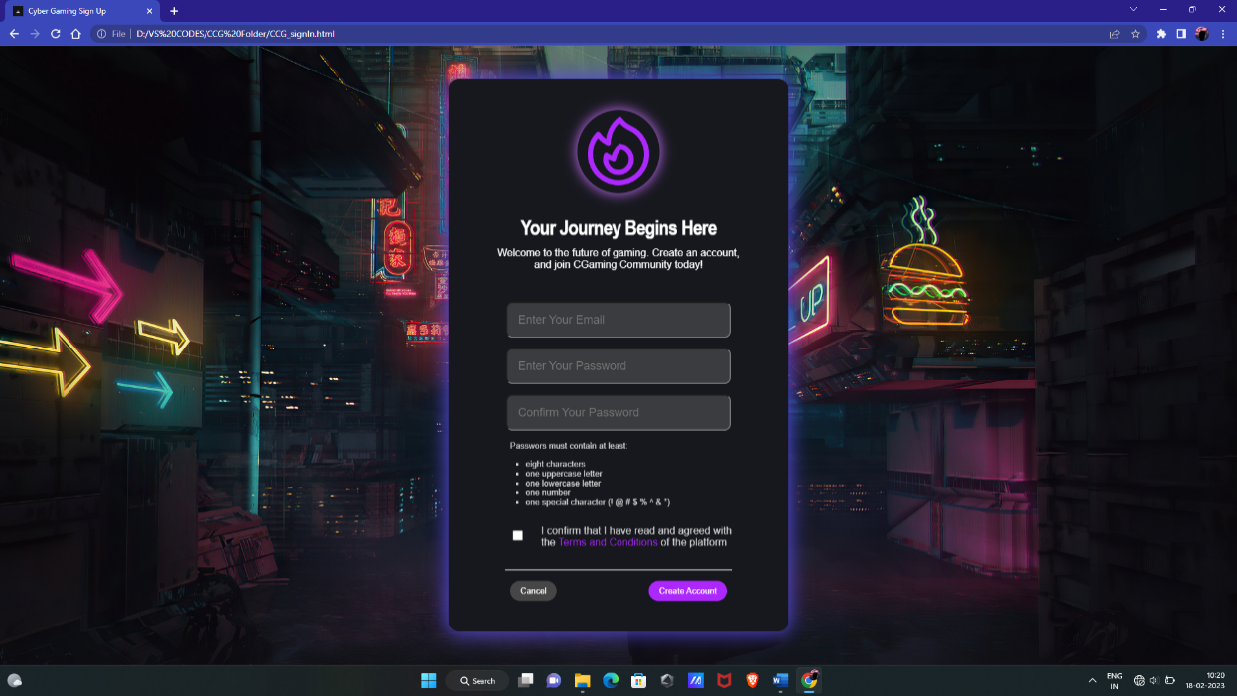

#### Fig.2.1. Sign Up Page

2.3.2 **HTML**

<!DOCTYPE html>

<html lang="en">

<head>

    <meta charset="UTF-8">

    <meta http-equiv="X-UA-Compatible" content="IE=edge">

    <meta name="viewport" content="width=device-width, initial-scale=1.0">

    <link rel="icon" href="triangle.jfif">

    <link rel="stylesheet" href="CCG_login stylesheet.css">

    <title>Cyber Gaming Sign Up</title>

</head>

<body>

        <!--PRE LOADER-->

        <div id="preLoader">  </div>

    <section class="signInBox" id="loginWindow">       <!--login code-->

        <div class="profileIconContainer">

            <svg xmlns="http://www.w3.org/2000/svg" fill="none" viewBox="0 0 24 24" stroke-width="1.5" stroke="currentColor" class="w-6 h-6"> </svg>

        </div>

        <div class="titleText"><b>Your Journey Begins Here</b></div>

        <p class="subtitle"> Welcome to the future of gaming. Create an account, and join CGaming Community today! </p>

        <section class="inputFields">

            <input class="usernameField" placeholder="Enter Your Email" type="text" id="Uname"  required/>

            <input class="passwordField" placeholder="Enter Your Password" type="password" id="Pword" required/>

            <input class="passwordField" placeholder="Confirm Your Password" type="password" id="CPword" required/>

        </section>

        <div class="conditions">

                <p>Passwors must contain at least:</p>

                <ul><li> eight characters </li>

                    <li> one uppercase letter </li>

                    <li> one lowercase letter </li>

                    <li> one number </li>

                    <li> one special character (! @ # $ % ^ & *) </li></ul>

                <div class="checkBoxConditions">

                    <input type="checkbox" class="checkbox" id="checkboxCondition"/> <div> I confirm that I have read and agreed with the <a href="_blank">Terms and Conditions</a> of the platform</div>

                </div>

            </div><hr>

        <section class="buttons">

            <button class="cancelButton" id="cancelButton">Cancel</button>

            <button class="createButton" onclick="createButton()">Create Account</button>

        </section>

    </section>

</body>

<script src="CCGSignIn.js"></script>

</html>

2.3.3 **CSS**

*{ box-sizing: border-box; }

body{

    font-family: Helvetica;

    background-size: cover;

    background-repeat: no-repeat;

    background-image: url('GameImage2.jpg');

}

/* sign in code */

.signInBox{

    display: block; color: white;

    position: fixed; border-radius: 1rem;

    height: auto; width: 33rem;

    top: 50%; left: 50%;

    padding: 1rem; text-align: center;

    box-shadow: 0px 0px 30px 3px black;

    transform: translate(-50%,-50%);

background: rgb(23, 24, 30);

    animation-name: loginBoxShadow;

    animation-duration: 9s; animation-delay: 0s;

    animation-play-state: running;

    animation-iteration-count: infinite;

}

.conditions{

    text-align: left; font-size: small;

    margin: 1rem auto 0rem 5rem; color: rgb(212, 212, 212);

}

.conditions ul{

    list-style-type: square; margin: 0rem 0rem 0rem -1rem;

}

.signInBox .profileIconContainer{

    margin: auto; padding: 2rem; text-align: center;

}

.signInBox .profileIconContainer svg{

    width: 8rem; color: rgb(173, 40, 255);

    border-radius: 50%;

    box-shadow: 0px 0px 20px 1px rgb(201, 114, 255);

}

.signInBox .titleText{

    text-align: center; font-size: 2rem;

    letter-spacing: -1px; font-stretch: condensed;

}

.subtitle{

    margin: 0.8rem auto 0rem auto;

}

.signInBox .inputFields{

    margin: 2rem auto 0rem auto;

}

.signInBox hr{

    margin: 2rem 4.5rem 0rem 4.5rem;

}

.signInBox .buttons{

    display: flex; margin: 1rem 5rem 2rem 5rem;

    text-align: center; justify-content: space-between;

}

.signInBox .buttons .cancelButton{

    border: none; background: rgb(70, 70, 70);

    border-radius: 2rem; padding: 0.5rem 1rem;

    color: white; font-size: small;

}

.signInBox .buttons .createButton{

    border: none; background: rgb(173, 40, 255);

    border-radius: 2rem; padding: 0.5rem 1rem;

    color: white; font-size: small;

}

.signInBox .buttons button:hover{

    background: rgb(84, 1, 148);

}

.signInBox .checkBoxConditions{

    font-size: medium;    display: block;    height: max-content;

}

.signInBox .checkBoxConditions .checkbox{

    width: 1rem;

}

.checkBoxConditions div{

    display: absolute; margin: -3rem 4rem 0rem 3rem;

}

.checkBoxConditions a{

    text-decoration: none; color: rgb(173, 40, 255);

}

.checkBoxConditions a:hover{

    color: rgb(0, 255, 157);

}

/* pre loader css */

#preLoader{

    background: rgb(0, 0, 0) url(loader.gif) no-repeat center center;

    background-size: 18%; height: 100vh; width: 100%;

    position: fixed; z-index: 100; display: block;

    margin: -1rem;

}

2.3.4 **JS**

//for preloader

const loader = document.getElementById("preLoader");

window.addEventListener("load", function(){

    loader.style.display= "none";

})

//for Sign In page

const Uname = document.getElementById("Uname");

const Pword = document.getElementById("Pword");

const CPword = document.getElementById("CPword");

function createButton(){

    if((Pword.value == CPword.value)&&(Uname.value =="player")){

        alert("Welcome Player");

        window.open("CCG_Main.html","_self");

    }

    else{

        alert("Invalid Credentials");

    }

}

#### AT CG SITE – LOGIN PAGE

2.4.1 **DESIGN**

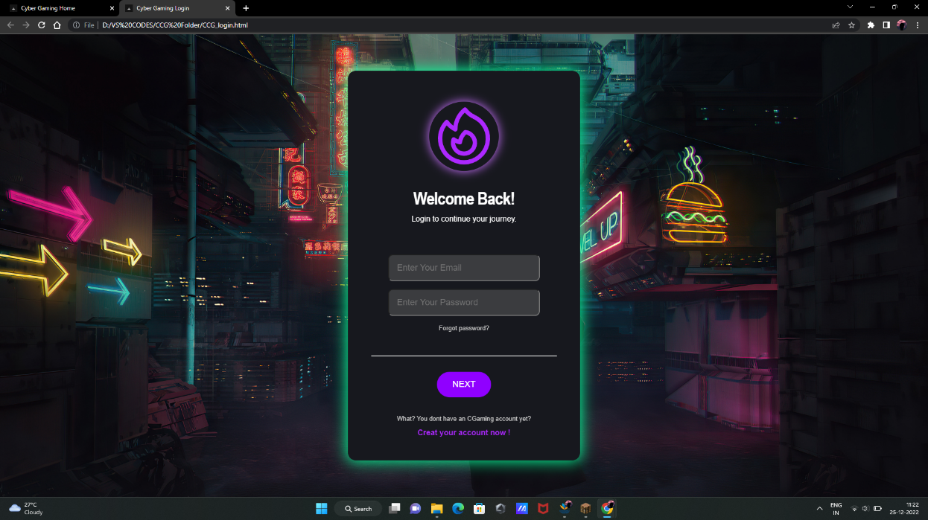

**Fig.2.2. Login Page**

2.4.2 **HTML**

<!DOCTYPE html>

<html lang="en">

<head>

    <meta charset="UTF-8">

    <meta http-equiv="X-UA-Compatible" content="IE=edge">

    <meta name="viewport" content="width=device-width, initial-scale=1.0">

    <link rel="icon" href="triangle.jfif">

    <link rel="stylesheet" href="CCG_login stylesheet.css">

    <title>Cyber Gaming Login</title>

</head>

<body>

    <!--PRE LOADER-->

    <div id="preLoader">  </div>

    <form class="loginBox" id="loginWindow">       <!--login code-->

        <div class="profileIconContainer">

            <svg xmlns="http://www.w3.org/2000/svg" fill="none" viewBox="0 0 24 24" stroke-width="1.5" stroke="currentColor" class="w-6 h-6"> </svg>

        </div>

        <div class="titleText"><b>Welcome Back!</b></div>

        <p class="subtitle"> Login to continue your journey. </p>

        <section class="inputFields">

                <input placeholder="Enter Your Email" type="text" name="username" id="username"  required/>

                <input placeholder="Enter Your Password"  type="password" name="password" id="password" required/>

        </section>

        <div class="forgotPass">

            <a href="_blank">Forgot password?</a>

        </div> <hr>

        <section class="buttons">

            <button class="nextButton" id="submitButton">NEXT</button>

            <p>What? You dont have an CGaming account yet?</p>

            <a class="subtitle" href="CCG_signIn.html">Creat your account now !</a>

        </section>

    </form>

</body>

<script src="CCGLogin.js"></script>

</html>

2.4.3 **CSS**

*{ box-sizing: border-box; }

body{

    font-family: Helvetica; background-image: url('GameImage2.jpg');

    background-repeat: no-repeat; background-size: cover;

}

/* login code */

.loginBox{

    display: block; color: white; position: fixed;

    border-radius: 1rem;  height: auto; width: 30rem;

    background: rgb(23, 24, 30); top: 50%; left: 50%;

    transform: translate(-50%,-50%); padding: 1rem;

    text-align: center; box-shadow: 0px 0px 30px 3px black;

    animation-name: loginBoxShadow; animation-duration: 9s;

    animation-play-state: running; animation-delay: 0s;

    animation-iteration-count: infinite;

}

@keyframes loginBoxShadow {

    0% {box-shadow: 0px 0px 30px 3px rgb(214, 207, 0);}

    25% {box-shadow: 0px 0px 30px 3px rgb(255, 132, 0);}

    50% {box-shadow: 0px 0px 30px 3px rgb(0, 255, 157);}

    75% {box-shadow: 0px 0px 30px 3px rgb(119, 0, 255);}

    100% {box-shadow: 0px 0px 30px 3px rgb(255, 0, 128);}

}

.profileIconContainer{

    margin: 1rem auto 0rem auto; padding: 2rem; text-align: center;

}

.profileIconContainer svg{

    width: 9rem; color: rgb(173, 40, 255);    border-radius: 50%;

    box-shadow: 0px 0px 20px 1px rgb(201, 114, 255);

}

.titleText{

    text-align: center; font-size: 2.3rem;

    letter-spacing: -1px; font-stretch: condensed;

}

.subtitle{

    font-size: medium; width: 80%; margin: 1rem auto 0rem auto;

}

input{

    margin-top: 1rem; width: 70%; height: 3.5rem;

    padding: 1rem; color: white; font-size: large;

    border-radius: 10px; background: rgba(95, 95, 95, 0.5);

    outline: none;

}

.inputFields{

    margin: 3rem auto 0rem auto;

}

.buttons{

    margin: 2rem auto; text-align: center;

}

.buttons p{

    font-size: small; color: rgb(199, 199, 199);

}

.buttons a{

    text-decoration: none; color: rgb(173, 40, 255);

    font-weight: bold;

}

.buttons a:hover{

    color: rgb(0, 255, 157);

}

.buttons .nextButton{

    border: none; background: rgb(144, 0, 255);

    border-radius: 2rem; padding: 1rem 2rem;

    color: white; font-size: large;

    margin-bottom: 1.5rem;

}

.buttons .nextButton:hover{

    background: rgb(84, 1, 148);

}

.forgotPass{

    margin: 1rem;

}

.forgotPass a{

    text-decoration: none; color: rgb(199, 199, 199);

    font-size: small;

}

.forgotPass a:hover{

    color: rgb(0, 255, 157);

}

hr{

    margin: 3rem 2rem 0rem 2rem;

}

2.4.3 **JS**

const loginForm = document.getElementById("loginWindow");

const loginButton = document.getElementById("submitButton");

const loginErrorMsg = document.getElementById("login-error-msg");

//for the login form and submit  button

loginButton.addEventListener("click", (e) => {

    e.preventDefault();

    const username = loginForm.username.value;

    const password = loginForm.password.value;

    if (username === "player" && password === "password") {

        alert("Welcome "+ username);

        window.open("CCG_Main.html","_parent");

    }

    else{

        document.getElementById("username").style.boxShadow=("0px 0px 8px 0px rgb(232, 35, 64)");

        document.getElementById("username").style.backgroundColor=("rgba(252, 3, 144,0.05)");

        document.getElementById("password").style.boxShadow=("0px 0px 8px 0px rgb(232, 35, 64)");

        document.getElementById("password").style.backgroundColor=("rgba(252, 3, 144,0.05)");

    }

})

## WEBSITE

### CHAPTER 3

**LANDING PAGE & HOME PAGE**

3.1.1  **PURPOSE OF A LANDING PAGE**

A landing page is created to get visitors to take a particular action—such as to purchase a subscription product or download an e-book. Unlike your homepage, a landing page is intended for only a small subset of your audience and thus can use targeted language to drive up conversion rates. So, to successfully convert lots of shoppers, you will want to create several unique landing pages that go after shoppers with different profiles. Each landing page will have targeted messaging that works to convince visitors to click the CTA.

3.1.2  **PURPOSE OF A HOME PAGE**

Your homepage is a firehose—a flood of information about you and what you sell presented in a visually appealing way. Its purpose is to introduce shoppers to your brand, your values, your collections, and your products. The brand can show visitors what they have to offer and build trust in their mission. The calls to action are numerous, and no individual call to action is emphasized over the rest. At this point, visitors are indistinguishable from each other. Traffic to the homepage comes from organic search, referrals, and brand awareness ads. This is the point from which a brand can begin to understand shopper behaviour, funnelling them into the right pages that can serve up more targeted messaging.

3.1.3  **DIFFERENCE - LANDING PAGE AND HOME PAGE**

In digital marketing, a landing page is a standalone web page, created specifically for a marketing or advertising campaign. It’s where a visitor “lands” after they click on a link in an email, or ads from Google, Bing, YouTube, Facebook, Instagram, Twitter, or similar places on the web. Unlike web pages, which typically have many goals and encourage exploration, landing pages are designed with a single focus or goal, known as a call to action (or CTA, for short). It’s this *focus* that makes landing pages the best option for increasing the conversion rates of your marketing campaigns and lowering your cost of acquiring a lead or sale.

**AT CG SITE - LANDING PAGE**

3.2.1  **DESIGN**

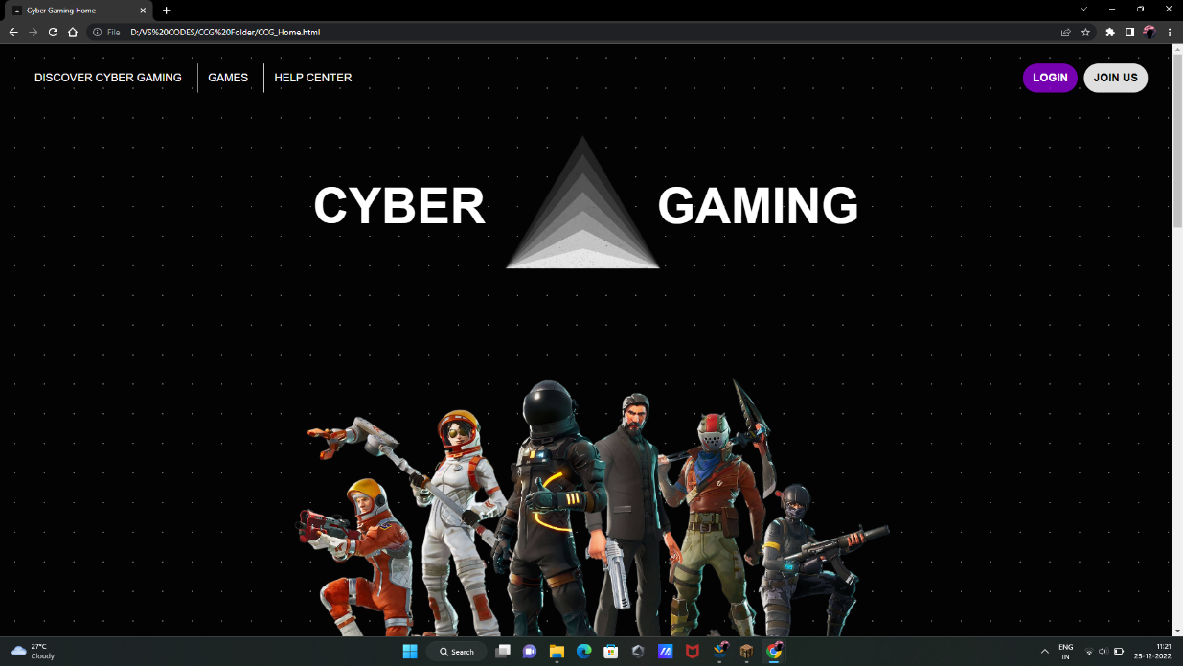

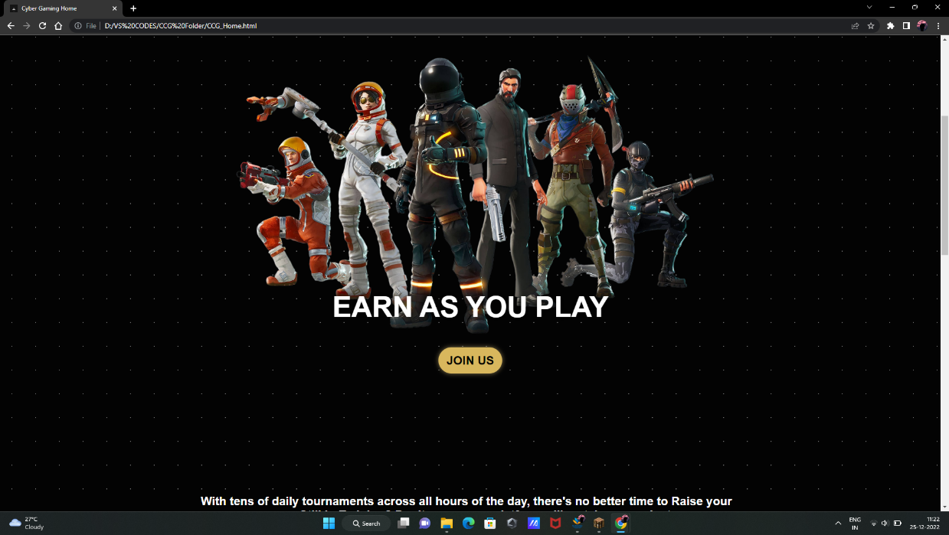

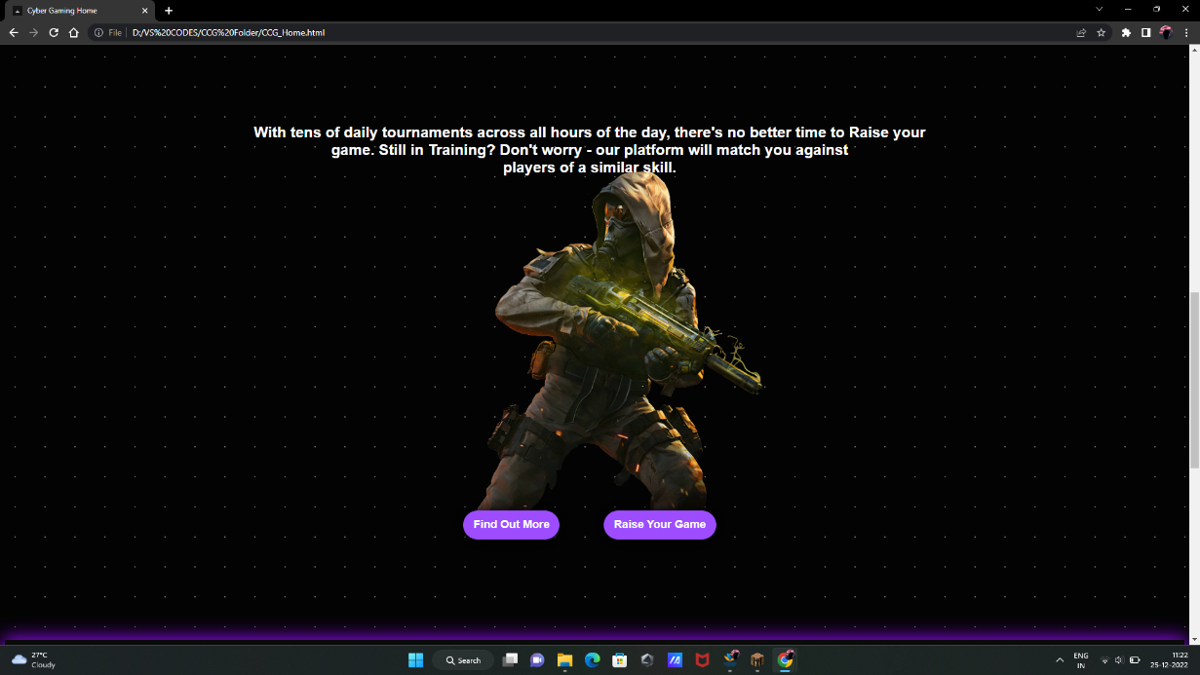

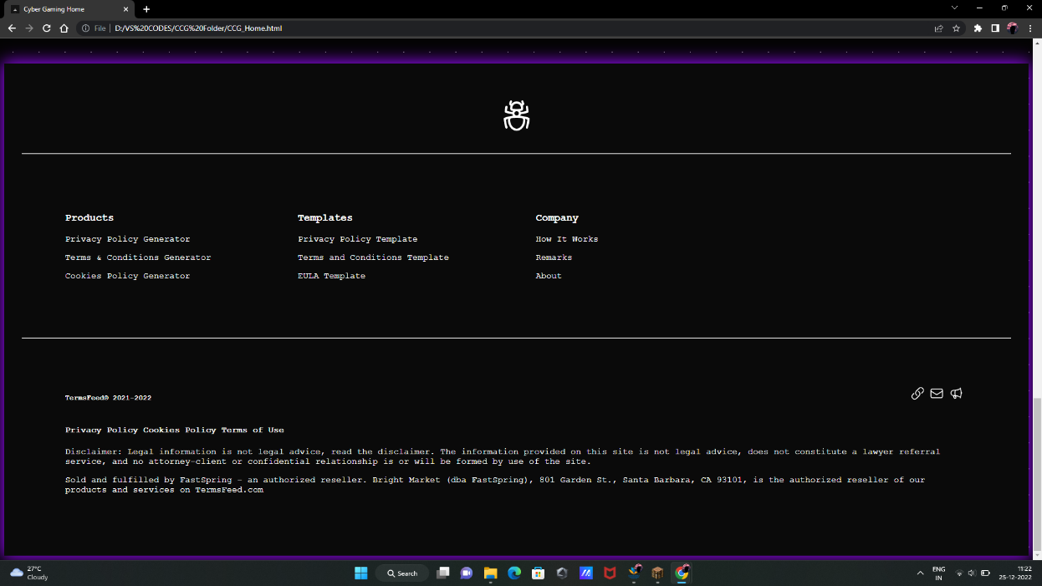

**Fig: 3.1. Landing Page**

3.2.2  **HTML**

<!DOCTYPE html>

<html lang="en">

<head>

    <meta charset="UTF-8">

    <meta http-equiv="X-UA-Compatible" content="IE=edge">

    <meta name="viewport" content="width=device-width, initial-scale=1">

    <title>Cyber Gaming Home</title>

    <link rel="icon" href="triangle.jfif">

    <link rel="stylesheet" href="CCG_home stylesheet.css">

</head>

<body>

    <!--PRE LOADER-->

    <div id="preLoader">  </div>

    <header>

        <div class="left_btn">

            <button class="home_btn" id="home_button">DISCOVER CYBER GAMING</button>

            <button class="games_btn" onclick="gameBtn()">GAMES</button>

            <button class="help_btn" onclick="helpBtn()">HELP CENTER</button>

        </div>

        <div class="right_btn">

            <button class="login_btn" onclick="login_button()">LOGIN</button>

            <button class="join_btn" onclick="joinBtn()">JOIN US</button>

        </div>

    </header>

    <section class="homePage"> <!--home page-->

        <div class="logoContainer">

            <div class="title">CYBER GAMING</div>

            <div><img src="TriangleLogo.png" alt="CG Logo"></div>

        </div>

        <div class="section1">

            <img src="GameImage6.png" alt="GameImage">

            <h1> EARN AS YOU PLAY </h1>

            <button class="join_btn" onclick="joinBtn()">JOIN US</button>

        </div>        <br> <br>

        <div class="section2">

                <p> With tens of daily tournaments across all hours of the day, there's no better time to Raise your game. Still in Training? Don't worry - our platform will match you against <br> players of a similar skill.</p>

                <img src="GameImage5 .png" alt="GameImage">

                <button onclick="links()"> Find Out More</button>

                <button onclick="links()"> Raise Your Game</button>

        </div>

    </section>

    <footer>

        <div class="logo">

            <svg xmlns="http://www.w3.org/2000/svg" fill="none" viewBox="0 0 24 24" stroke-width="1.5" stroke="currentColor" class="w-6 h-6"> </svg>

        </div>

        <hr>

        <section class="footer_columns">

            <div class="column">  <h3>Products</h3>

                <p>Privacy Policy Generator</p>

                <p>Terms & Conditions Generator</p>

                <p>Cookies Policy Generator</p>

            </div>

            <div class="column">  <h3>Templates</h3>

                <p>Privacy Policy Template</p>

                <p>Terms and Conditions Template</p>

                <p>EULA Template</p>

            </div>

            <div class="column">  <h3>Company</h3>

                <p>How It Works</p>

                <p>Remarks</p>

                <p>About</p>

            </div>

        </section>

        <hr>

        <div class="terms">

            <div class="links">

                <h5>TermsFeed©️ 2021-2022</h5>

                <div class="social_links">

                    <svg xmlns="http://www.w3.org/2000/svg" fill="none" viewBox="0 0 24 24" stroke-width="1.5" stroke="currentColor" class="w-6 h-6"> </svg>

                    <svg xmlns="http://www.w3.org/2000/svg" fill="none" viewBox="0 0 24 24" stroke-width="1.5" stroke="currentColor" class="w-6 h-6"> </svg>

                    <svg xmlns="http://www.w3.org/2000/svg" fill="none" viewBox="0 0 24 24" stroke-width="1.5" stroke="currentColor" class="w-6 h-6"> </svg>

                </div>

            </div>

            <h4>Privacy Policy  Cookies Policy  Terms of Use</h4>

            <p>Disclaimer: Legal information is not legal advice, read the disclaimer. The information provided on this site is not legal advice, does not constitute a lawyer referral service, and no attorney-client or confidential relationship is or will be formed by use of the site.</p>

            <p>Sold and fulfilled by FastSpring - an authorized reseller. Bright Market (dba FastSpring), 801 Garden St., Santa Barbara, CA 93101, is the authorized reseller of our products and services on TermsFeed.com</p>

        </div>

    </footer>

</body>

<script src="CCGMain.js"></script>

</html>

3.2.3  **CSS**

*{ box-sizing: border-box; }

body{

    font-family: 'Courier New', Courier, monospace;

    background-size: cover;     background: rgb(3, 3, 3);

    background-image: radial-gradient(rgb(110, 110, 110) 1px, transparent 0);

    background-size: 48px 48px;

}

header{

    height: 5rem; padding: 1rem; margin: 1rem;

    display: flex; justify-content: space-between;

    flex-direction: row;

}

header button{

    border: none; padding: 0.8rem 1rem; color: white;

    font-size: large; background: none; cursor:pointer;

}

header .games_btn , .help_btn{

    border-left: 1px solid white;

}

header .left_btn button:hover{

    color: rgb(123, 48, 180);

}

header .right_btn button{

    font-weight: bold; border-radius: 27px;

    box-shadow: 0px 0px 5px 0.5px black; color: white;

}

header .right_btn .login_btn{

    background: rgba(167, 0, 251, 0.7);

}

header .login_btn:hover{

    background: rgba(193, 70, 255, 0.7);

}

header .right_btn .join_btn{

    background: rgb(223, 223, 223); color: black;

}

header .join_btn:hover{

    background: rgb(216, 183, 93);

}

/* main page */

.homePage{

    display: block; margin: 1rem auto; width: 60%;

    padding: 10px; font-family: Helvetica;

}

.homePage .logoContainer{

    display: block; color: white; font-weight: bold;

    margin: 6rem auto; text-align: center;

}

.homePage .title{

    word-spacing: 16rem; font-size: 5rem;

}

.homePage .logoContainer img{

    width: 27%; margin: -12rem 0rem 0rem 0rem;

}

.section1{

    position: relative; text-align: center;    padding: 1rem;

    margin-bottom: 10rem;

}

.section1 h1{

    color: white; text-shadow: 0rem 0rem 1rem black;

    font-size: 3.6rem; word-spacing: -1px;

    font-weight: bolder;  margin: -8rem auto 2rem auto;

}

.section1 img{

    width: 100%;    border-radius: 2rem;

}

.section1 button{

    border: none;    padding: 0.8rem 1rem;    font-size: x-large;

    cursor:pointer;    border-radius: 27px;

    font-weight: bold;    margin: 1rem auto 0rem auto;

}

.section1 .join_btn{

    background: rgb(223, 223, 223);     color: black;

    box-shadow: 0px 0px 30px 3px black;

}

.section1 .join_btn:hover{

    background: rgb(216, 183, 93);

    box-shadow: 0px 0px 10px 0px rgba(255, 226, 147, 0.5);

}

.section2{

    color: white; font-size: x-large;    font-weight: bold;

    text-align: center; height: 40rem;

    margin: 5rem 0rem 5rem -1rem;     position: relative;

}

.section2 p{

    position: absolute; margin-top: -3rem;

}

.section2 img{

    width: 90%; border-radius: 2rem;

}

.section2 button{

    border: none; padding: 0.8rem 1rem; color: white;

    font-size: large; background: rgb(157, 77, 255);

    cursor:pointer; box-shadow: 0px 0px 30px 3px black;

    border-radius: 27px;  font-weight: bold;

    margin: -4rem 2rem auto 2rem;

}

.section2 button:hover{

    background: rgb(99, 30, 182);

    box-shadow: 0px 0px 10px 0px rgba(181, 97, 255, 0.5);

}

/* footer */

footer{

    background:rgba(10, 10, 10); color: white; text-align: center;

    height: max-content; padding: 2rem; bottom: 0;

    left: 0; position: relative;

    box-shadow: 0px 0px 30px 3px rgb(153, 11, 255);

    box-sizing: content-box; margin-top: 3rem;

}

footer .logo{

    margin: 2rem auto; width: 4rem;

    transition: rotate 1.8s, color 1.8s;

}

footer .logo:hover{

    rotate: 540deg; color: rgb(103, 0, 182);

}

footer .footer_columns{

    display: flex; flex-direction: row;

}

footer .column{

    margin: 5rem; text-align: left;

}

footer .terms{

    text-align: left; margin: 5rem;

}

footer .links{

    display: flex; justify-content: space-between;

}

footer .links .social_links{

    margin: 0.5rem; color: white;

}

footer .links .social_links svg{

    width: 26px; padding: 0px;

}

footer .links .social_links svg:hover{

    padding: 1px; color: rgb(144, 0, 255);

}

/* pre loader css */

#preLoader{

    background: rgb(0, 0, 0) url(loader.gif) no-repeat center center;

    background-size: 18%; height: 100vh; width: 100%;

    position: fixed; z-index: 100;    display: block; margin: -1rem;

}

3.2.4  **JS (same for landing page and home page)**

function login_button(){

    window.open("CCG_login.html", "_blank");

}

function joinBtn(){

    window.open("CCG_signIn.html","_blank");

}

function links(){

    window.open("#","_blank");

}

function helpBtn(){

    window.open("CCG_helpCenter.html","_blank");

}

function gameBtn(){

    window.open("CCG_GameSection.html", "_blank");

}

// in the main page //the announcements box on the left for the change of news (whatsnew or Records)

        function latestRecordsBtn(){

            var WNBox = document.getElementById("whatsNewBox");

            var LRBox = document.getElementById("latestRecordsBox");

            WNBox.style.display = "none";

            LRBox.style.display = "block";

        }

        function whatsNewBtn(){

            var WNBox = document.getElementById("whatsNewBox");

            var LRBox = document.getElementById("latestRecordsBox");

            WNBox.style.display = "block";

            LRBox.style.display = "none";

        }

//chat box input script

function sendBtn(){

    let chatBoxInput = document.getElementById("chatBoxInput");

    let myChatInput = document.getElementById("myChatInput");

    //return if nothing was entered

    if (!chatBoxInput) return;

    myChatInput.style.display=("block");

    myChatInput.innerHTML = chatBoxInput.value;

//declaring the input value to the p tag to display as a chat

    chatBoxInput.value = [];

}

**AT CG SITE - HOME PAGE**

3.3.1  **DESIGN**

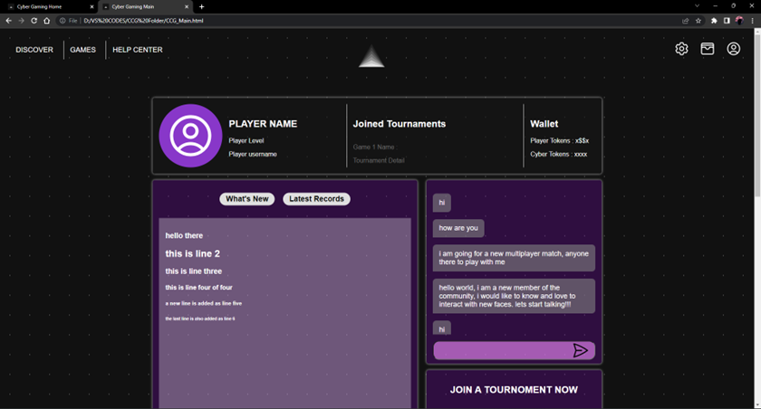

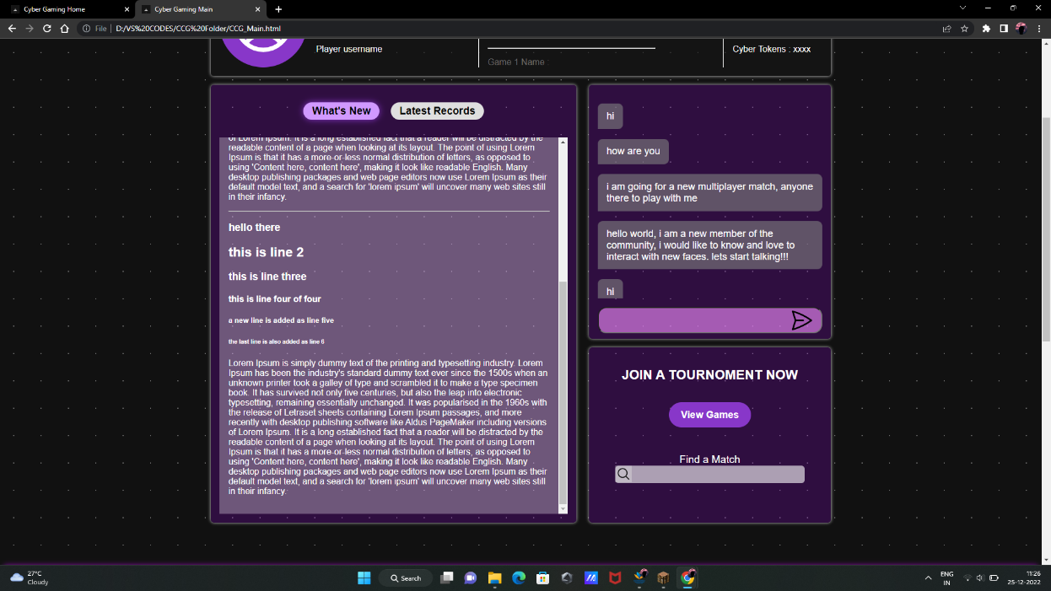

**Fig: 3.2. Home Page – What’s New**

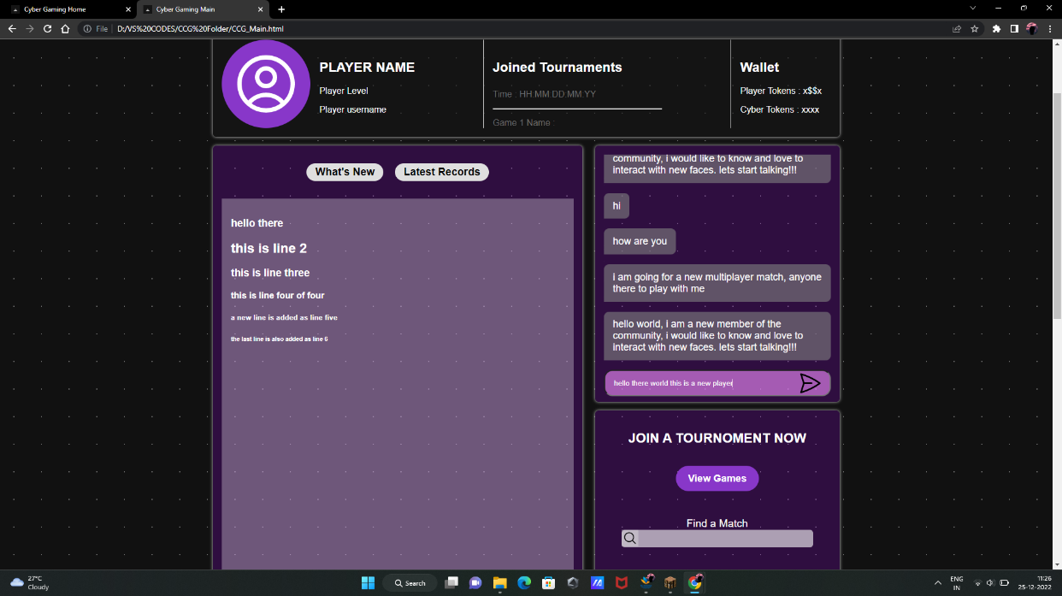

**Fig: 3.3. Home Page – Chat Box Input & Latest records**

3.3.2  **HTML**

<body>

    <!--PRE LOADER-->

    <div id="preLoader">  </div>

    <header> <!--header section-->

        <div class="left_btn">

            <button class="home_btn" id="home_button">DISCOVER </button>

            <button class="games_btn" onclick="gameBtn()">GAMES</button>

            <button class="help_btn" onclick="helpBtn()">HELP CENTER</button>

        </div>

        <img src="TriangleLogo.png" alt="CG logo">

        <div class="right_btn">

            <!--Settings Icon-->

            <svg xmlns="http://www.w3.org/2000/svg" fill="none" viewBox="0 0 24 24" stroke-width="1.5" stroke="currentColor" class="w-6 h-6"> </svg>

            <!--Wallet Icon-->

            <svg xmlns="http://www.w3.org/2000/svg" fill="none" viewBox="0 0 24 24" stroke-width="1.5" stroke="currentColor" class="w-6 h-6"> </svg>

            <!--Profile Icon-->

            <svg xmlns="http://www.w3.org/2000/svg" fill="none" viewBox="0 0 24 24" stroke-width="1.5" stroke="currentColor" class="w-6 h-6"> </svg>

        </div>

    </header>

    <section class="mainPage"> <!--main page-->

        <div class="aboutProfile"> <!--Profile Box-->

            <div class="leftContent">

                <div class="profileBox">

                    <div class="profileIcon"> <!--profile icon-->

                        <svg xmlns="http://www.w3.org/2000/svg" fill="none" viewBox="0 0 24 24" stroke-width="1.5" stroke="currentColor" class="w-6 h-6"> </svg>

                    </div>

                    <div class="details"> <!-- profile details -->

                            <h1> PLAYER NAME </h1>

                            <p> Player Level </p>

                            <p> Player username </p>

                    </div>

                </div>

            </div>

            <div class="middleContent">

                <h2> Joined Tournaments </h2>

                <div class="tournamentContainer" id="tournamentContainer">

                    <div id="tournament">

                        <p>Game 1 Name :</p>

                        <p>Tournament Detail</p>

                        <p>Time : HH:MM:DD:MM:YY </p>

                    </div> <hr>

                    <div id="tournament">

                        <p>Game 1 Name :</p>

                        <p>Tournament Detail</p>

                        <p>Time : HH:MM:DD:MM:YY </p>

                    </div>

                </div>

            </div>

            <div class="rightContent">

                <h2> Wallet </h2>

                <div>

                    <p>Player Tokens : x$$x </p>

                    <p>Cyber Tokens : xxxx </p>

                </div>

            </div>

        </div>

        <section class="categories"> <!-- contents of the main page-->

            <div class="newsBox" id="box"> <!-- content on left ===> news and updates -->

                <div class="options">

                    <button class="btn1" onclick="whatsNewBtn()">What's New</button>

                    <button class="btn2" onclick="latestRecordsBtn()">Latest Records</button>

                </div>

                <div class="whatsNewBox" id="whatsNewBox"> <!--whats new box -->

                    <h1> hello there </h1>

                    <h2> this is line 2 </h2>

                    <h3> this is line three </h3>

                    <h4> this is line four  of four </h4>

                    <h5> a new line is added as line five </h5>

                    <h6> the last line is also added as line 6 </h6>

                    <p> Lorem Ipsum is simply dummy text … their infancy.</p>

                    <hr>

                </div>

                <div class="latestRecords" id="latestRecordsBox"> <!-- latest records of global players -->

                    <h1> hello there </h1>

                    <h2> this is line 2 </h2>

                    <h3> this is line three </h3>

                    <h4> this is line four  of four </h4>

                    <h5> a new line is added as line five </h5>

                    <h6> the last line is also added as line 6 </h6>

                    <p></p>

                </div>

            </div>

            <div>

                <div class="chatBoxContainer" id="box"> <!--Chat Box Container-->

                    <div class="chatBox">

                        <div class="worldChats"> <!-- chats are to be displayed-->

                            <div class="oldWorldChat"> <!-- old chats chats-->

                                <div id=”oldText”></div>

                            <div class="newWorldChat"><!--new inputed chat here-->

                                <p>hello there world this is a new player</p>

                            </div>

                        </div>

                    </div>

                    <div class="inputSection">

                            <input type="text" id="newChatInput"/>

                            <svg xmlns="http://www.w3.org/2000/svg" fill="none" viewBox="0 0 24 24" stroke-width="1.5" stroke="currentColor" class="w-6 h-6"> </svg>

                    </div>

                </div>

                <div class="eventListBox" id="box"> <!-- new tournoment tab-->

                    <h2>JOIN A TOURNOMENT NOW</h2>

                    <button>View Games</button><br>

                    <form>

                        <label> Find a Match</label> <br>

                        <div class="searchBar">

                            <input type="search" id="search bar" />

                            <svg xmlns="http://www.w3.org/2000/svg" fill="none" viewBox="0 0 24 24" stroke-width="1.5" stroke="currentColor" class="w-6 h-6"> </svg>

                        </div>

                    </form>

                </div>

            </div>

        </section>

    </section>

    <footer>

        Footer section as same as all pages

    </footer>

</body>

<script src="CCGMain.js"></script>

</html>

3.3.3  **CSS**

*{    box-sizing: border-box; }

body{

    font-family: 'Courier New', Courier, monospace;

    background-size: cover; background: rgb(17, 17, 17);

    background-image: radial-gradient(rgb(110, 110, 110) 0.8px, transparent 0);

    background-size: 50px 50px;

}

header{

    height: 5rem; padding: 1rem; justify-content: space-between;

display: flex; margin: 1rem 0 5rem 0; flex-direction: row;

}

header button{

    border: none; padding: 0.8rem 1rem; color: white;

    font-size: large; background: none;

}

header img{

    margin: 0 0 0 -15rem; width: 5rem; height: 5rem;

}

header .games_btn , .help_btn{

    border-left: 1px solid white;

}

header .left_btn button:hover{

    color: rgb(123, 48, 180);

}

header .right_btn svg{

    color: white; width: 2.5rem; margin: auto 0.5rem;

}

/* main page */

        /* Top Player details container */

.mainPage{

    display: block; margin: 1rem auto; width: 60%;

    font-family: helvetica,sans-serif; color: white;

}

.mainPage .aboutProfile{

    display: flex; border-radius: 6px; width: 100%;

    justify-content: space-between; height: 12rem;

    background-color: rgba(21, 21, 21, 0.6);

    box-shadow: 0px 0px 6px 0px rgb(207, 207, 207);

}

.aboutProfile .leftContent{

    padding: 1rem;

}

.aboutProfile .middleContent, .rightContent{

    margin: 1rem; padding: 1rem; border-left: 1px solid white;

}

.leftContent .profileBox{

    display: flex;

}

.proileBox .profileIcon{

    width: max-content; margin: 1rem;

}

.profileIcon svg{

    color: white; width: 10rem; background: rgb(136, 55, 201);

    border-radius: 50%; padding: 1rem;

}

.profileBox .details{

    margin: 1rem;

}

.middleContent{

    width: 30%; overflow: hidden;

}

.middleContent .tournamentContainer{

    overflow: scroll; position: relative; height: 10rem;

    color: rgb(110, 110, 110);

}

.tournamentContainer::-webkit-scrollbar{

    display: none;

}

.eventListBox{

    padding: 1rem; text-align: center;

}

.eventListBox button{

    background: rgb(136, 55, 201); border: none; margin: 1rem;

    padding: 0.8rem 1.4rem; border-radius: 2rem;

    font-size: large; color: white; font-weight: bold;

}

.eventListBox button:hover{

    box-shadow: 0px 0px 9px 0px black; padding: 0.8rem 1.6rem;

}

.eventListBox form{

    margin: 1rem; padding: 1rem;

}

.eventListBox .searchBar{

    display: flex; flex-wrap: wrap; text-align: center; margin: auto;

}

.eventListBox input{

    border: none; margin: auto; background: rgba(255, 255, 255, 0.6);

    height: 2rem; width: 100%; padding: 3px;

    border-radius: 6px;   overflow: hidden;   outline: none;

}

.eventListBox label{

    font-size: larger;

}

.eventListBox svg{

    width: 30px; color: black; position: absolute;

    background: rgb(225, 225, 225, 0.4); padding: 2px;

}

        /* main page content */

.categories{

    display: grid; grid-template-columns: 59% 39% ;

    grid-gap: 2%; margin: 1rem auto 5rem auto;

}

.categories .newsBox, .chatBoxContainer, .eventListBox, .box4, .box5, .box6{

    box-shadow: 0px 0px 6px 0px rgb(207, 207, 207);

    background: rgba(167, 0, 251, 0.2); border-radius: 6px;

}

.categories .newsBox{

    height: 50rem; width: auto; padding: 1rem;

    text-align: center;

}

.categories .chatBoxContainer{

    height: 29rem; width: auto; justify-content: center;

    align-items: center;  font-size: large;   padding: 1rem;

}

.categories .eventListBox{

    height: 20rem; width: auto; margin-top: 1rem;

}

.newsBox button{

    font-weight: bold; font-size: larger; padding: 0.3rem 1rem;

    border-radius: 27px;  background: rgb(223, 223, 223);

    color: black; border: none; margin: 1rem 0.5rem;

}

.newsBox button:hover{

    box-shadow: 0px 0px 12px 0px rgb(136, 55, 201);

    background: rgb(209, 153, 255); cursor: pointer;

}

.newsBox .whatsNewBox{

    display: none; margin: 1rem auto;  overflow-y: auto;

    text-align: left; height: 43rem; padding: 1rem;

    overflow-x: hidden;   background: rgba(255, 255, 255, 0.3);

}

.newsBox .latestRecords{

    display: block; margin: 1rem auto; text-align: left;

    background: rgba(255, 255, 255, 0.3); height: 43rem;

    padding: 1rem; overflow-x: hidden; overflow-y: auto;

}

.chatBox{

    height: 23.4rem; overflow: hidden; overflow-y: scroll;

    position: relative;

}

.chatBox::-webkit-scrollbar {

    display: none;

}

.chatBox .oldWorldChat{

    padding: 0; margin: 0; text-align: left;

}

.chatBox .newWorldChat{

    right: 0; position: absolute; text-align: right;

}

.oldWorldChat p{

    background: rgba(128, 128, 128, 0.6); padding: 0.8rem 1rem;

    border-radius: 9px 9px 9px 0px; width: fit-content;

    text-align: left;

}

.newWorldChat p{

    background: rgba(242, 212, 147, 0.6); padding: 0.8rem 1rem;

    border-radius: 9px 9px 0px 9px; width: fit-content;

    text-align: right;

}

.inputSection{

    display: flex;

}

.inputSection input{

    width: 100%; height: 3rem; border-radius: 1rem; outline: none;

    cursor: text; margin-top: 1rem;   overflow: hidden; padding-left: 1rem;

    color: white; background: rgba(244, 141, 255, 0.6);

}

.inputSection svg{

    width: 45px; margin-top: 18px; margin-left: 350px;    position: absolute;

    color: black;

}

3.3.4  **JS**

function login_button(){

    window.open("CCG_login.html", "_blank");

}

function joinBtn(){

    window.open("CCG_signIn.html","_blank");

}

function links(){

    window.open("#","_blank");

}

function helpBtn(){

    window.open("CCG_helpCenter.html","_blank");

}

function gameBtn(){

    window.open("CCG_GameSection.html", "_blank");

}

// in the main page

    //the announcements box on the left

        //for the change of news (whatsnew or Records)

        function latestRecordsBtn(){

            var WNBox = document.getElementById("whatsNewBox");

            var LRBox = document.getElementById("latestRecordsBox");

            WNBox.style.display = "none";

            LRBox.style.display = "block";

        }

        function whatsNewBtn(){

            var WNBox = document.getElementById("whatsNewBox");

            var LRBox = document.getElementById("latestRecordsBox");

            WNBox.style.display = "block";

            LRBox.style.display = "none";

        }

//chat box input script

function sendBtn(){

    let chatBoxInput = document.getElementById("chatBoxInput");

    let myChatInput = document.getElementById("myChatInput");

    //return if nothing was entered

    if (!chatBoxInput) return;

    myChatInput.style.display=("block");

    myChatInput.innerHTML = chatBoxInput.value;         //declaring the input value to the p tag to display as a chat

    chatBoxInput.value = [];

}

# ADDITIONAL PAGES

### CHAPTER 4

### CATEGORIES PAGE

4.1.1  **WHAT IT IS**

A category page is a type of web page on a website that lists a collection of items, products, or articles that belong to a specific category or topic. The purpose of a category page is to help visitors easily navigate a website by grouping related content together in a structured and organized manner. Typically, category pages contain a title or heading that describes the category, a short description or summary of what the category includes, and a list of links or thumbnails that represent the items or articles within the category. They are an essential part of website design and can improve the overall user experience by making it easier for visitors to find what they are looking for.

4.1.2 **DESIGN**

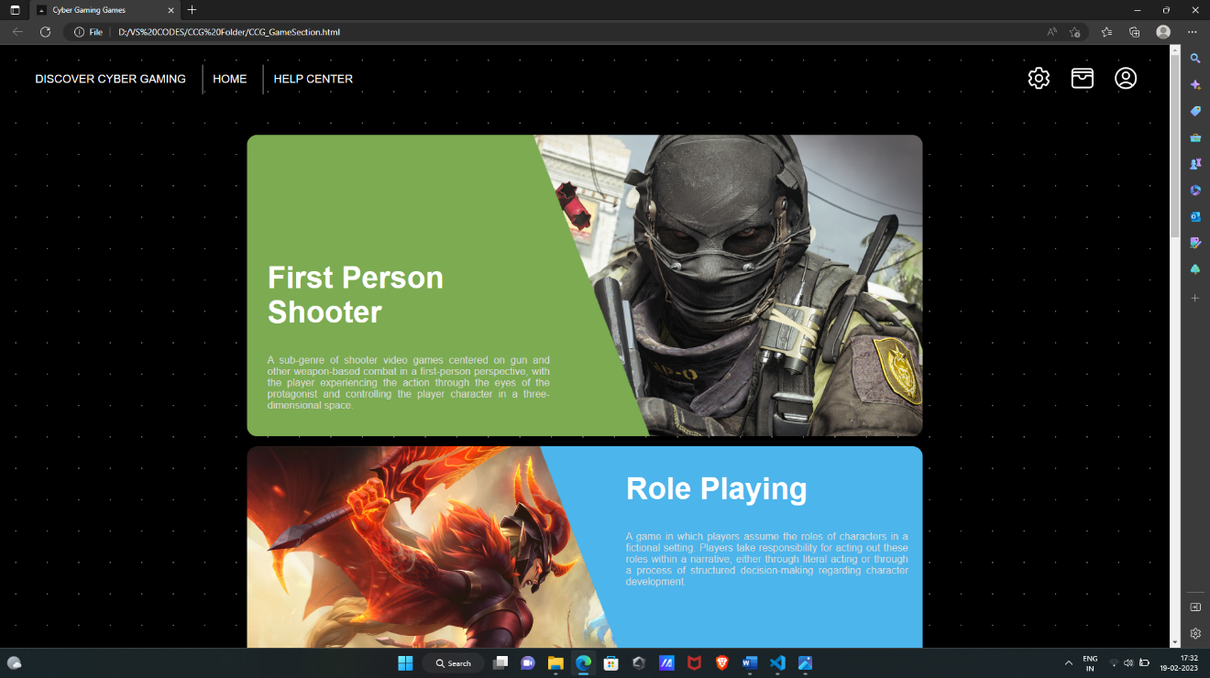

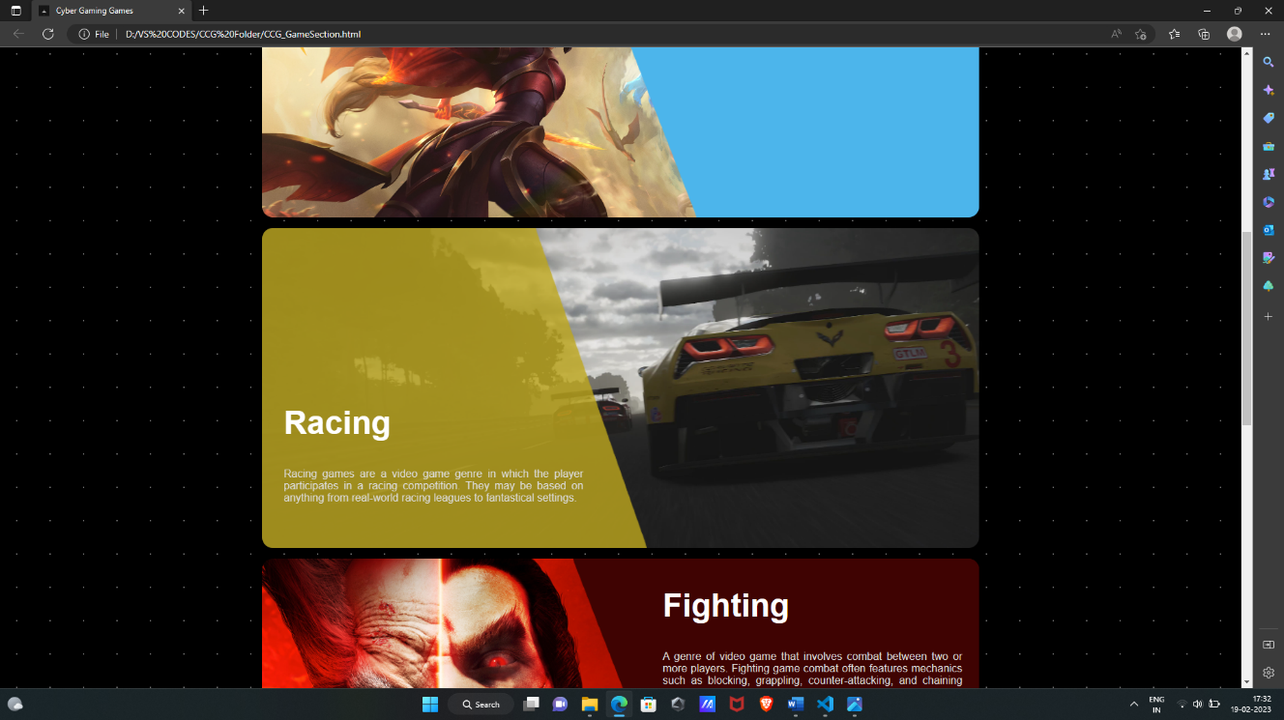

#### Fig.4.1. Categories page

4.1.3 **HTML**

<body>

    <!--PRE LOADER-->

    <div id="preLoader">  </div>

    <header> <!--Header content-->

        <div class="left_btn">

            <button class="home_btn" id="home_button">DISCOVER CYBER GAMING</button>

            <button class="games_btn" onclick="homeBtn()">HOME</button>

            <button class="help_btn" onclick="helpBtn()">HELP CENTER</button>

        </div>

        <div class="right_btn">

            <!--Settings Icon-->

            <svg xmlns="http://www.w3.org/2000/svg" fill="none" viewBox="0 0 24 24" stroke-width="1.5" stroke="currentColor" class="w-6 h-6"> </svg>

            <!--Wallet Icon-->

            <svg xmlns="http://www.w3.org/2000/svg" fill="none" viewBox="0 0 24 24" stroke-width="1.5" stroke="currentColor" class="w-6 h-6"> </svg>

            <!--Profile Icon-->

            <svg xmlns="http://www.w3.org/2000/svg" fill="none" viewBox="0 0 24 24" stroke-width="1.5" stroke="currentColor" class="w-6 h-6"> </svg>

        </div>

    </header>

    <section class="mainPage"> <!--main page-->

        <div class="game1">        <!-- First Person Shooter -->

            <div class="slider" name="categoryContainer" >

                <img src="Trapezoid1.png"  id="categoryFPS" class="trapezoidLeft" alt="Trapezoid image">

                <div class="titleContent">

                    <h1>First Person Shooter</h1>

                    <p>A sub-genre of … three-dimensional space.</p>

                </div>

            </div>

        </div>

        <div class="game2">        <!-- Role Playing -->

            <div class="slider" name="categoryContainer">

                <img src="Trapezoid2.png" id="categoryRPG"  class="trapezoidRight" alt="Trapezoid image">

                <div class="titleContent">

                    <h1>Role Playing</h1>

                    <p>A game in which … character development.</p>

                </div>

            </div>

        </div>

        <div class="game3">         <!-- Racing -->

            <div class="slider" name="categoryContainer">

                <img src="Trapezoid3.png" id="categoryRacing" class="trapezoidLeft" alt="Trapezoid image">

                <div class="titleContent">

                    <h1>Racing</h1>

                    <p>Racing games … fantastical settings.</p>

                </div>

            </div>

        </div>

        <div class="game4">         <!-- Fighting -->

            <div class="slider" name="categoryContainer">

                <img src="Trapezoid4.png"  id="categoryFighting" class="trapezoidRight" alt="Trapezoid image">

                <div class="titleContent">

                    <h1>Fighting</h1>

                    <p> A genre of video … attacks together into "combos".</p>

                </div>

            </div>

        </div>

    </section>

</body>

<script src="CCGGame.js"></script>

</html>

4.1.4 **CSS**

*{ box-sizing: border-box; }

body{

    font-family: 'Courier New', Courier, monospace;

    background-size: cover; background: black;

    background-image: radial-gradient(rgb(110, 110, 110) 0.8px, transparent 0);

    background-size: 50px 50px;

}

header{

    height: 5rem; padding: 1rem; margin: 1rem;

    display: flex; justify-content: space-between;

    flex-direction: row;

}

header button{

    border: none; padding: 0.8rem 1rem; color: white;

    font-size: large;   background: none;

}

header .games_btn , .help_btn{

    border-left: 1px solid white;

}

header .left_btn button:hover{

    color: rgb(123, 48, 180);

}

header .right_btn svg{

    color: white; width: 2.7rem; margin: auto 0.5rem;

}

/* main page */

.mainPage{

    width: 60%; height: max-content; padding: 1rem;

    border-radius: 1rem; margin: 1rem auto;

}

.mainPage .game1, .game2, .game3, .game4{

    width: 100%; height: 30rem; border-radius: 1rem;

    background-size: cover; overflow: hidden;    margin: 1rem auto;

}

.game1{

    background-image: url(CODMW.jpg);

}

.game2{

    background-image: url(League.jpg);

}

.game3{

    background-image: url(Forza.jpg);

}

.game4{

    background-image: url(Tekken.jpg);

}

.trapezoidLeft{

    width: 50rem; height: 30rem; transition: width 2s, opacity 2s;

    cursor: pointer;

}

.trapezoidRight{

    width: 50rem; height: 30rem; transition: transform 2s, opacity 2s;

    opacity: 100%; transform: translate(38%,0%);

}

.game1:hover .trapezoidLeft{

    width: 45rem; opacity: 80%;

}

.game3:hover .trapezoidLeft{

    width: 45rem; opacity: 80%;

}

.game2:hover .trapezoidRight{

    transform: translate(43%,0%); opacity: 80%;

}

.game4:hover .trapezoidRight{

    transform: translate(43%,0%); opacity: 80%;

}

.slider{

    display: block; color: white;

}

.titleContent{

    position: absolute; padding: 1rem; font-family: Helvetica;

    width: 30rem;

}

.titleContent p{

    text-align: justify; color: rgb(219, 219, 219);

}

.titleContent h1{

    font-size: 3rem;

}

.game1 .titleContent{

    top: 30%; left: 22%;

}

.game2 .titleContent{

    top: 65%; right: 21.5%; z-index: 50;

}

.game3 .titleContent{

    top: 140%; left: 22%;

}

.game4 .titleContent{

    top: 168.5%; right: 21.6%;

}

/* pre loader css */

#preLoader{

    background: rgb(0, 0, 0) url(loader.gif) no-repeat center center;

    background-size: 18%; height: 100vh; width: 100%;

    position: fixed; z-index: 100; display: block;

    margin: -1rem;

}

4.1.5 **JS**

//for preloader

const loader = document.getElementById("preLoader");

window.addEventListener("load", function(){

    loader.style.display= "none";

})

//functions for the header buttons

const redirectBtn = document.getElementById("home_button");

redirectBtn.onclick=()=>{

    window.open("#","_blank");

}

function homeBtn(){

    window.open("CCG_Main.html","_self");

}

function helpBtn(){

    window.open("CCG_helpCenter.html","_blank");

}

//functions to redirect when each game category is clicked

const cateFPS = document.getElementById("categoryFPS");

const cateRPG = document.getElementById("categoryRPG");

const cateRacing = document.getElementById("categoryRacing");

const cateFighting = document.getElementById("categoryFighting");

cateFPS.addEventListener("click",()=>{

    window.open("google.com","_parent");

})

cateRPG.addEventListener("click",()=>{

    window.open("google.com","_parent");

})

cateRacing.addEventListener("click",()=>{

    window.open("google.com","_parent");

})

cateFighting.addEventListener("click",()=>{

    window.open("google.com","_parent"); })

### HELP CENTER

4.2.1  **PURPOSE OF A HELP CENTER**

The purpose of a help center page on a website is to provide a centralized location for users to find answers to their questions and solutions to common issues related to using the website or its products/services. Help center pages typically contain a searchable knowledge base that includes articles, tutorials, and frequently asked questions (FAQs) that address various topics and problems. In addition to written content, help center pages may also feature multimedia resources such as videos and images to enhance the user's understanding of the information.

4.2.2 **DESIGN**

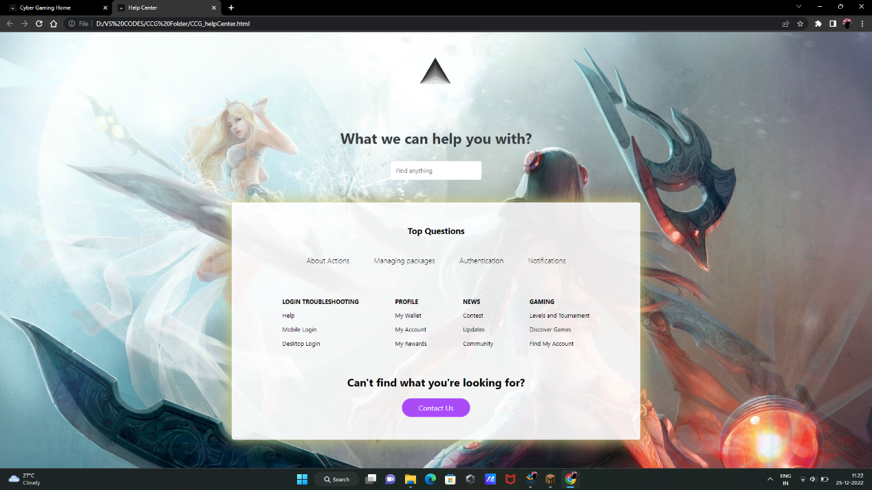

**Fig.4.2. Help center page**

4.2.2 **HTML**

  <body>

    <!--PRE LOADER-->

    <div id="preLoader">  </div>

    <div class="icon">

      <img src="TriangleLogo.png" alt="CG logo">

    </div>

    <div class="title">

      <h1>What we can help you with?</h1>

      <input type="search" placeholder="Find anything" />

    </div>

    <div class="container">

      <h3>Top Questions</h3>

      <div class="articles">

        <div> <h4>About Actions</h4> </div>

        <div> <h4>Managing packages</h4> </div>

        <div> <h4>Authentication</h4> </div>

        <div> <h4>Notifications</h4>         </div>

      </div>

      <footer class="footer">

        <div> <h5>Login Troubleshooting</h5>

          <ul>

            <li><a href="#">Help</a></li>

            <li><a href="#">Mobile Login</a></li>

            <li><a href="#">Desktop Login</a></li>

          </ul>

        </div>

        <div> <h5>Profile</h5>

          <ul>

            <li><a href="#">My Wallet</a></li>

            <li><a href="#">My Account</a></li>

            <li><a href="#">My Rewards</a></li>

          </ul>

        </div>

        <div> <h5>News</h5>

          <ul>

            <li><a href="#">Contest</a></li>

            <li><a href="#">Updates</a></li>

            <li><a href="#">Community</a></li>

          </ul>

        </div>

        <div> <h5>Gaming</h5>

          <ul>

            <li><a href="#">Levels and Tournament</a></li>

            <li><a href="#">Discover Games</a></li>

            <li><a href="#">Find My Account</a></li>

          </ul>

        </div>

      </footer>

      <div class="more-info">

        <h2>Can't find what you're looking for?</h2>

        <button>Contact Us</button>

      </div>

    </div>

  </body>

  <script href="CCG_helpCenter.js"></script>

</html>

4.2.3 **CSS**

body{

   background-image: url(LOL.jpg);

   font-family:-apple-system, BlinkMacSystemFont, 'Segoe UI', 'Open Sans', 'Helvetica Neue', sans-serif;

}

* {

    margin: 0;    padding: 0;    box-sizing: border-box;

  }

  ul {    list-style-type: none;  }

  a {    text-decoration: none;  }

  button {

    padding: 10px 15px;    width: 150px;    border-radius: 60px;

    color: #fff;    border: none;    background: rgb(170, 75, 248);

    font-family: inherit;    font-size: medium;

  }

  .icon{

    width: 5rem;    color: white;    margin: 3rem auto 0rem auto;

  }

  .icon img{

    width: 5rem;

  }

  button:hover {

    cursor: pointer;    background-color: rgb(197, 127, 255);

    color: var(--primary-color);

  }

  .title {

    text-align: center;    padding: 50px 0;    color: #fff;

  }

  .title h1 {

    padding: 30px;    color: rgb(54, 60, 62);

  }

  .title input {

    padding: 12px;    width: 200px;    border: none;    border-radius: 4px;

    font-family: inherit;

  }

  .title input::placeholder {

    font-family: inherit;

  }

  .container {

    padding: 50px;    max-width: 900px;    margin: 0 auto 50px;

    border-radius: 5px;    background-color: rgba(255, 255, 255, 0.9);

    animation: containerAnime 9s infinite;    animation-play-state:running;

    animation-timing-function: ease-out;

  }

  @keyframes containerAnime {

    0% {box-shadow: 0px 0px 30px 3px rgb(118, 243, 220);}

    50% {box-shadow: 0px 0px 30px 3px rgb(235, 186, 95);}

    100% {box-shadow: 0px 0px 30px 3px rgb(68, 100, 114);}

}

  .container h3 {

    text-align: center;    padding-bottom: 20px;

  }

  .container .articles {

    display: flex;    flex-wrap: wrap;    align-items: center;

    justify-content: center;

  }

  .container .articles div {

    margin: 0 5px 30px;    border: 2px solid transparent;

    border-radius: 5px;    padding: 20px;

  }

  .container .articles div h4 {

    font-weight: 300;

  }

  .container .footer {

    display: flex;    flex-wrap: wrap;    align-items: center;

    justify-content: center;

  }

  .container .footer div {

    padding: 20px;    margin: 0 20px 30px;

  }

  .container .footer h5 {

    font-size: 13px;    text-transform: uppercase;    margin-bottom: 10px;

  }

  .container .footer div ul li {

    margin: 10px 0;

  }

  .container .footer div ul li a {

    color: var(--primary-color);    font-size: 13px;

  }

  .container .footer div ul li a:hover {

    border-bottom: 2px dotted var(--primary-color);

  }

  .container .more-info {

    text-align: center;

  }

  .container .more-info h2 {

    margin-bottom: 20px;

  }

  @media (max-width: 900px) {

    .container { margin: 0 30px; }

  }

  @media (max-width: 500px) {

    .title h1 { font-size: 24px; }

    .container .articles,

    .container .footer {

      display: grid;      grid-template-columns: 1fr;      place-items: center;

    }

    .container .footer {

      text-align: center;

    }

    .container .more-info h2 {

      font-size: 20px;

    }

  }

## CONCLUSION AND FUTURE SCOPE

#### CHAPTER 5

**5.1 CONCLUSION**

An online e-sports gaming platform is an exciting and rapidly growing industry that has a lot of potential. It has already gained a significant following and has become a multi-billion dollar industry. The platform offers a way for people to come together and compete against each other in a virtual world, allowing them to showcase their skills and win prizes. The platform is also a great way for companies to advertise their products and services to a highly engaged audience.

#### 5.2 FUTURE SCOPE

The future of online e-sports gaming platforms looks bright. As technology continues to improve, it is expected that the quality of the gaming experience will also improve. This could include better graphics, more realistic game environments, and improved gameplay. In addition, the growth of e-sports tournaments and leagues will likely continue, offering even more opportunities for players to compete against each other.

As the industry grows, it is likely that more companies will enter the market, offering new and innovative products and services to players. This could include new gaming platforms, new games, and even new types of tournaments and competitions. With the increasing popularity of e-sports, it is also possible that it could become an Olympic sport in the future.

Overall, the future of online e-sports gaming platforms is very exciting, and there is no doubt that the industry will continue to grow and evolve in the coming years.

#### REFERENCES

* W3 SCHOOLS – for code and syntax references

Available: <https://www.w3schools.com/>

* UI-GRADIENTS – for color and gradient choices

Available: <https://uigradients.com/>

* HERO ICONS – for svg icons

Available: <https://heroicons.com/>

* ICON SCOUT – for svg icons

Available: <https://iconscout.com/icons/>